Exposure Control Plan

Company Name | [Company Name]
Company Website | [Company Website]
Address | [Address]
Contact Information  (Names & Phone Numbers) | [Contact Person A] | [Phone A]
 | [Contact Person B] | [Phone B]

Health Hazards of COVID-19

COVID-19 is a disease caused by the coronavirus. It is very contagious. All Canadian provinces and territories have declared it a public health emergency. The World Health Organization has declared it a global pandemic. That means the disease has spread across a large part of the world and affects a large part of the population.

COVID-19 can make breathing difficult and lead to hospitalization or death. Its effects could be more dangerous than regular flu. This is a new disease so most people will not be immune. Seniors and people with other health issues such as heart disease, diabetes, and lung disease have a greater risk of hospitalization or death. But COVID-19 does not discriminate; it attacks the young and the healthy, too.
Symptoms

The most common symptoms are fever, tiredness and a dry cough. Some people have difficulty breathing. Some get cold symptoms like sneezing, sore throat, or runny nose. Some people have no symptoms.
How it Spreads

People catch COVID-19 from other people by:
- Breathing in droplets in the air from other people coughing or sneezing.
- Being in close contact with other people (e.g., shaking hands or hugging).
- Touching a surface that has the virus on it and then touching your face or food. The virus can enter your body through your eyes, nose, or mouth, so keep your hands off your face!
NOTE: You could transfer the virus if you touch a surface that has the virus on it and then touch another surface.

People who have symptoms of COVID-19 should not come to work. COVID-19 can be spread by people who do not show symptoms. People who may have been in contact with COVID-19 should not come to work, even if they have no symptoms. This includes people who:
- Have travelled outside of Canada within the previous 14 days (including the USA).
- Have been exposed to someone with COVID-19.
- Live with someone who has symptoms of COVID-19.
- Live with someone who has been exposed to COVID-19.

Our Purpose

It is very important at [Company Name] that we provide a safe and healthy workplace for all staff. We will use several ways to reduce exposure to COVID-19 in our workplace. This will include the most effective control methods available now. Our work procedures will protect our workers and drivers and other workers and drivers who enter our facilities. All employees must follow the procedures in this plan. We all have a role to play in preventing or reducing our exposure to COVID-19.

Responsibilities
Employer Responsibilities

[Company Name] will:
- Ensure that the supplies and resources needed to set up and follow the Exposure Control Plan are available. Supplies include gloves, alcohol-based hand rubs, and washing facilities. Resources include worker training materials and current COVID-19 bulletins and notices.
- Ensure that workers are able to stay 2 metres/6 feet apart (physical distancing) at all times.
- Set up and explain the best control methods for each site.
- Make sure that we teach supervisors and workers how to work safely by following the Exposure Control Plan. This includes how and when to report exposures.
- Make sure that workers use the proper personal protective equipment (PPE) (e.g., gloves, eye protection, and respirators). Wear this equipment along with PPE that would regularly be required.
- Review the plan’s effectiveness regularly. We will also review the control methods that will make sure we have the best plan and it is successful.
- Maintain records of training and inspections.
- Make sure that a copy of the Exposure Control Plan is available to all workers.

Supervisor Responsibilities

[Company Name] supervisors will:
- Make sure they instruct workers properly on how to control hazards at the worksite.
- Make sure that workers have been fit tested for proper respirators and that they are using their respirators. Supervisors will also make sure these details are recorded.
- Ensure that workers practise physical distancing.
- Direct work in a way that eliminates or minimizes the risk to workers.
Worker Responsibilities

[Company Name] workers will:
- Maintain physical distance by staying 2 metres/6 feet from others.
- Know the hazards of the workplace.
- Follow work procedures as directed by the employer or supervisor.
- Follow instructions for using any required PPE.
- Report any unsafe conditions or acts to the supervisor.
- Report exposures in the way they have been trained.

Identify and Assess the Risk

There are three main ways to spread COVID-19. They all need to be controlled. These include close contact, droplets in the air, and surface contact.
Droplets in the Air

BCCDC says coronavirus is not transmitted through airborne transmission (when bacteria or viruses travel on dust particles in the air). COVID-19 travels in larger droplets sprayed out when someone coughs or sneezes. The droplets can spray as far as 2 metres and are too large to float in the air. But, if somebody coughs or sneezes close to you, you could inhale the droplets. Yes, that’s gross. And dangerous. So, make sure you stay at least 2 metres away from others.
Close Contact

Close contact means physical contact with another person, such as shaking hands or hugging. When people cough or sneeze, especially into their hands, the droplets will be on their skin or clothing. The droplets on their hands or clothing can transfer to others during close contact.

Surface Contact
An object becomes contaminated when an infected person sneezes or coughs on it or touches it. Droplets land on it. Surface contact happens when a worker touches a contaminated object and then touches their face. Droplets enter the worker. Researchers have not figured out how long the COVID-19 virus stays contagious on different surfaces. It varies with the type of surface, humidity and temperature. Stay safe! Clean your hands often with soap and water or an alcohol-based hand rub.

The risk assessment table below has been adapted from WorkSafeBC Regulation Guideline G6.34-6. We used this guideline as a reference to determine that the risk level of our workers is low when they maintain physical distancing. Our workers work on a(n) [Enter Company Choice] work site and have little, moderate, or lengthy contact with the general public.

Assess the Risk of COVID-19

 | Low Risk  Workers who typically have no contact with people infected with COVID-19 | Moderate Risk  Workers who may be exposed to infected people from time to time in relatively large, well- ventilated workspaces | High Risk  Workers who may have contact with infected patients, or with infected people, in small, poorly ventilated workspaces
Hand hygiene | Yes (washing with soap and water, using an alcohol-based hand rub, or using hand wipes that contain effective disinfectant) | Yes (washing with soap and water, using an alcohol-based hand rub, or using hand wipes that contain effective disinfectant) | Yes (washing with soap and water, using an alcohol-based hand rub, or using hand wipes that contain effective disinfectant)
Disposable gloves | Not required | Not required (unless handling contaminated objects regularly) | Yes, in some cases (for example, when working directly with COVID-19 patients)
Aprons, gowns, or similar body protection | Not required | Not required | Yes, in some cases (for example, when working directly with COVID-19 patients)
Eye protection such as goggles or face shield | Not required | Not required | Yes, in some cases (for example, when working directly with COVID-19 patients)
Airway protection - respirators | Not required | Not required (unless likely to be exposed to coughing and sneezing) | Yes (at minimum use N95 respirator or equivalent)

Control the Risk

The WorkSafeBC Regulation requires employers to use infectious disease controls in the following order:
- Engineering controls
- Administrative controls
- Personal protective equipment (PPE)

We do not need to use engineering controls in our workplace. Our risk of exposure can be controlled by using administrative controls (physical distancing, washing hands, cleaning surfaces, and using cough/sneeze etiquette). We can also use PPE (respirators).
Handwashing

Washing your hands is one of the best ways to reduce the risk of infection. Proper handwashing helps prevent transferring virus particles from the hands to other parts of the body—especially the eyes, nose, and mouth—or to other surfaces.

Wash your hands immediately:
- Before leaving a work area
- After handling anything that may be contaminated
- Before eating, drinking, smoking, handling contact lenses, or applying makeup.
Handwashing Procedure
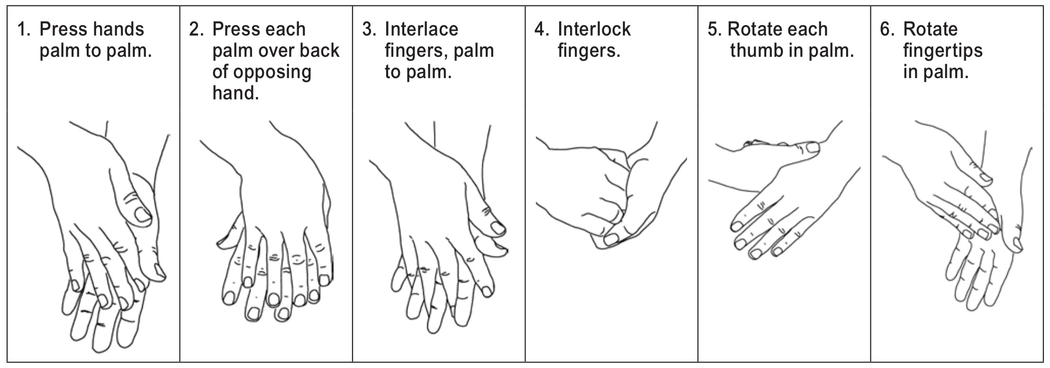

Remove jewellery. Use soap and warm running water—it doesn’t have to be hot to do the job. Wet your hands, then apply soap. Wash the fronts and backs of your hands. Work soap under your fingernails and between fingers for at least 20 seconds. Rinse well. Dry your hands with a paper towel or clean towel. If water is not available, use a waterless hand cleaner that has at least 70% alcohol. Follow the manufacturer’s instructions on how to use the cleaner.

There are dispensers of alcohol-based hand sanitizer in the following locations:
[List Locations]

Cough/Sneeze Etiquette

[Company Name] workers are expected to follow cough/sneeze etiquette to reduce the risk of spreading the virus by droplets. Cough/sneeze etiquette includes:
- Teaching workers about control methods, including handwashing.
- Posting signs at entrances to instruct everyone about control methods.
- Covering your mouth and nose with a sleeve or tissue or coughing or sneezing into your elbow.
- Using tissues to contain what comes out when you cough or sneeze and then throwing tissues in a waste container right away.
- Offering surgical masks to people who are coughing or sneezing.
- Turning your head away from others when coughing or sneezing.
- Washing hands immediately after coughing or sneezing. Wash them regularly throughout your day/shift as well.

If Workers Show Symptoms of COVID-19

If workers have COVID-19 or show symptoms of having it, they must stay home. If they develop symptoms of COVID-19 while at work, they should leave. Workers should only return to work when they have medical clearance that they have recovered from COVID-19. Workers must inform their manager or supervisor if they have symptoms of COVID-19, feel ill, or have been diagnosed with COVID-19.

Workers who suspect they may have COVID-19 can use the BC Self-Assessment Tool at https://covid19.thrive.health or call 811 for assistance.

Training our Workers

[Company Name] workers will be trained in the following:
- The risk of exposure to COVID-19, and the symptoms of the disease.
- Safe work procedures to be used, including handwashing, physical distancing and cough/sneeze etiquette.
- Location of washing facilities, including dispensing stations for alcohol-based hand rubs.
- How to seek first aid.
- How to report an exposure to or symptoms of COVID-19.

Monitoring our Health

If [Company Name] workers have symptoms of COVID-19, they will report them right away to their manager or supervisor.

Keeping Records

[Company Name] will keep records of instruction and training we have provided to workers about COVID-19. We will keep exposure reports as well.

Annual Review

[Company Name] will review the Exposure Control Plan every year. We will update it as necessary by working with our joint health and safety committee or worker health and safety representative.

