Identifying hazards
Your first step in protecting workers involves accurately identifying potential hazards in your workplace. You're looking for all the things and situations that could possibly harm your workers or other workers that may be on site.
Identifying hazards starts with a workplace inspection. This includes walking around your site:
- Observing how work tasks are being performed
- Assessing the equipment workers are using, and considering how that equipment is being used
- Analyzing the design and layout of the work areas
This is a proactive process. Ask yourself, what is it about the activities, processes, or substances used that could injure your workers or harm their health?
Hazards generally arise from the following aspects of work:
- The physical work environment
- Equipment, materials, and substances used at the workplace
- Work tasks and how they are performed
- Work design and management
When you work in a place every day, it's easy to overlook some hazards. Here are some tips to help you identify risks in your workplace:
- For equipment, check manufacturer instructions or safety data sheets. Think about long-term health hazards such as high levels of noise.
- Consider non-routine operations, such as maintenance, cleaning operations, or changes in production cycles.
- For chemicals, check manufacturer instructions or safety data sheets. Remember to think about long-term health hazards such as exposure to harmful substances.
- Do an overall review of your incident and worker health records, as well as records of near misses or worker complaints. These can help identify less obvious hazards. People tend to deal with incidents as they occur, but viewing all that has occurred over time can alert you to a pattern and help you identify a hazard that may be systemic. If you're a large employer, our Employer Health and Safety Planning Tool Kit may help.
- Consult with your workers about any health and safety issues they've encountered in their work. It is important to keep lines of communication open with your workers, as they can likely identify risks to both workers and production. Survey them anonymously, asking open-ended questions. You may even choose to recognize workers who identify hazards in advance, since this helps business in the long run.
- Keep up with the information about hazards and risks relevant to your specific industry or type of work. Consult with industry associations, manufacturers, and suppliers — all of which can provide you with valuable information. Also check out our Industry Safety Information Centre, which shows detailed data for any industry.
- Review our resources and information on common risks in specific industries, including common hazards and exposures and tools, equipment, and machinery.
Once you have a documented list of hazards, you're ready to begin assessing and controlling the risks.

Assessing risks
As an employer, you need to conduct a systematic risk assessment to help you identify the hazards that exist in your workplace, and how they may put your workers at risk. To determine if you’ve done enough to protect your workers, it helps to use a rating system as part of your risk assessment.

When to do a risk assessment
Risk assessments are a proactive process designed to ensure workers are protected. Specific risk assessment requirements for organizations in B.C. are defined in different parts of the Occupational Health and Safety Regulation. A number of required health and safety processes are forms of risk assessment, such as workplace inspections and investigations. As a best practice, a full-site risk assessment will help you plan for better worker protection.
If your organization is small and you're confident you understand what's involved, you can likely do the risk assessment yourself — you don't need to be a health and safety expert. If your organization is larger, involve the worker health and safety representative or the joint health and safety committee. It's your responsibility as the employer to make sure the assessment is done properly.
If you have multiple work locations, be sure to do a risk assessment for each workplace. The hazards, and the risks they pose, may be different from place to place.
After you've completed your risk assessments, be sure to review them regularly to ensure they are accurate for your specific needs. Risk assessments should be reviewed whenever you introduce new equipment, materials, or work processes. At a minimum, make sure you update your risk assessments annually.
A risk assessment is not about creating huge amounts of paperwork. Instead, it's about understanding how your workers may be harmed and identifying reasonable measures to control those risks in your workplace. Your risk assessment will help determine whether you've covered everything.

Decide who might be harmed and how
For each hazard, you need to be clear about the groups of people who might be harmed. This will help you identify the best way of controlling the risk. Be sure to ask your workers if there are any groups you may have missed.
Here are some things to keep in mind:
- Certain groups of workers may have specific requirements according to the OHS Regulation. These groups may include new and young workers, temporary workers, contractors, and those working alone.
- Make sure you have included notifications and training for people who might not be in the workplace all the time, such as visitors, contractors, or maintenance workers.
- Take members of the public into consideration if they could be hurt by your activities.
- If you share your workplace with another business, consider how your work affects the workers from that business (and vice versa).

Determine the level of risk
Part of the risk assessment is determining the level of risk that hazards pose to workers. Rate the risks as high, medium, or low. This helps you decide which risks are most serious and should be dealt with first.
For example, a busy loading dock where workers are frequently carrying heavy loads could be a high risk for pallet jack collisions and a moderate risk for back strains.
To help evaluate the risk level, try to answer the following questions:
- Who might be harmed? For example, are all workers exposed to the hazard, or is it a smaller number?
- What kind of injury or illness could be suffered, and how severe would it most likely be?
- How long are workers typically exposed to the hazard? The longer the exposure, the higher the risk.
- How frequent is the exposure? If the task is repeated many times each shift, it usually carries more risk than a task done only occasionally.
Use this risk matrix table to help determine level of risk:
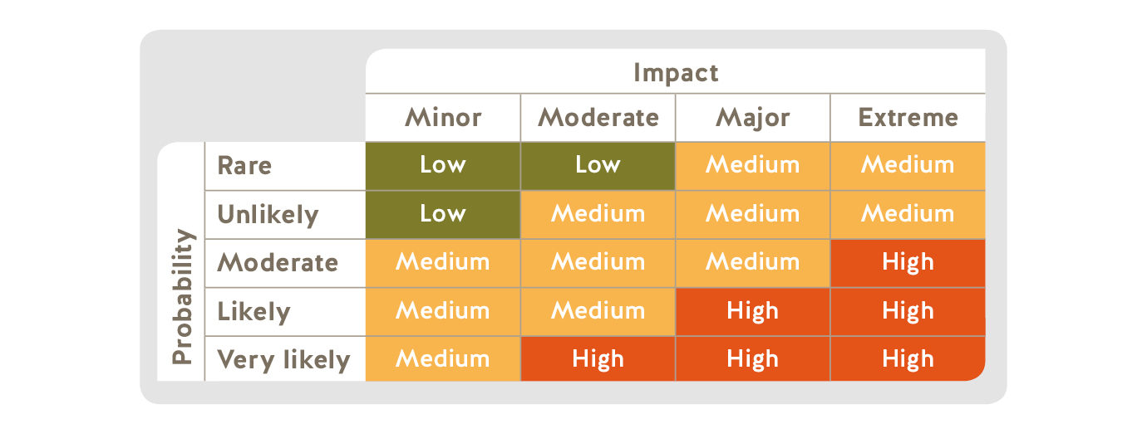

Record your findings
Be sure to record the findings of your risk assessment, as these will be the primary tool you will rely on to control the risks in your workplace. This includes noting the hazards, how people might be harmed by them, and what's already in place to control the risk. This documentation doesn't need to be complicated, and it can help you communicate and manage risks in your workplace.

Controlling risks
Once you've completed a risk assessment in your workplace, those risks that you have identified as high or moderate may require additional controls. You must correct unsafe conditions.
The highest risk should be addressed first. If you cannot eliminate a risk, you’ll need to implement control measures to minimize the risk. The hierarchy of controls can help you systematically take action to minimize risk.

The hierarchy of controls
When considering how to reduce the risk, there's a certain order you should follow. This is called the hierarchy of controls. It's important to follow the hierarchy, as shown below, rather than start with the easiest control measures.
Note that while the controls are listed in order of effectiveness, all four types of controls should be considered. They often work best in combination. For example, first responders cannot eliminate risks by choosing not to enter a burning building, but they can use engineering controls, administrative controls, and personal protective equipment and clothing to minimize the risks when they enter that building.

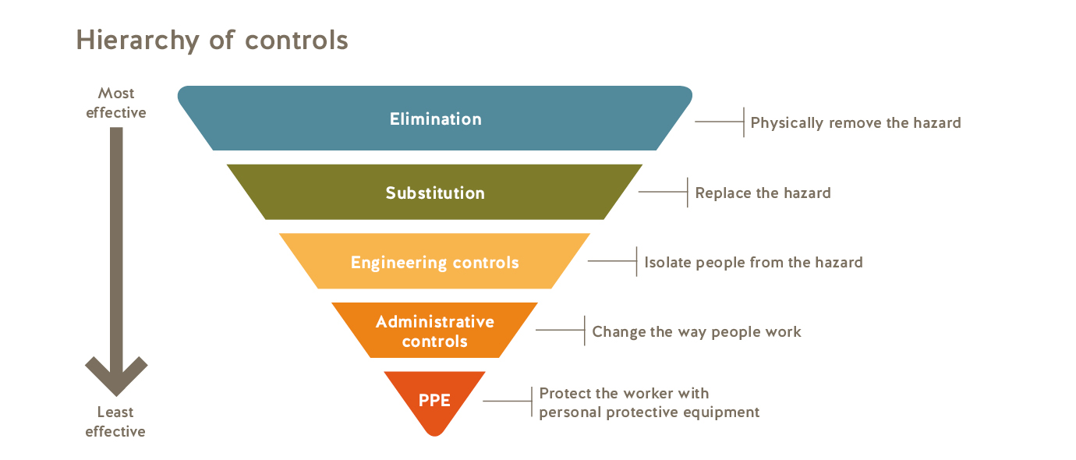
1

Elimination or substitution
Eliminating the hazard completely is always the first choice. Substitution involves replacing the material or process with a less hazardous one.
When considering these options, ask yourself:
  - Can I find safer ways to perform the task? For example, if falling is a hazard, eliminate the risk by storing stock at lower heights so workers don't have to climb ladders to reach the goods.
  - Can I use something less harmful? For example, if chemical-heavy industrial cleaners are a hazard, consider substituting cleaners made of vinegar and water mixed with salt, borax, or baking soda. Just make sure the substitutions don't create new hazards.
2

Engineering controls
If you can't eliminate the hazards or substitute safer alternatives, engineering controls are the next best options. These involve using work equipment or other means to prevent workers from being exposed to a hazard. Engineering controls are physical changes to the workplace and may include equipment guarding, guardrails, traffic control lanes and barriers between vehicles and pedestrians, and many other options.
For example, while working at heights cannot be avoided in construction, guardrails can be installed to prevent falls from happening. Guardrails are an example of an engineering control.
3

Administrative controls
Administrative controls involve identifying and implementing safe work procedures so your workers can perform their job duties safely. The findings of your risk assessment will form the basis of these safe work procedures.
Examples of administrative controls include implementing person-check procedures and prohibiting the use of mobile phones while workers are driving.
4

Personal protective equipment and clothing
Using personal protective equipment (PPE) is another important control to protect workers.
For example, while working with toxic chemicals may be necessary in certain workplaces such as laboratories, the use of PPE such as protective eyewear and gloves will help to reduce the exposure risk. Similarly, first responders enter hazardous sites as a regular part of their job, but they diligently use various types of PPE to protect themselves.

Monitoring control measures
Improving health and safety doesn't have to be costly, but the potential return on investment is huge. For example, placing a mirror on a dangerous, blind corner of your worksite can help prevent vehicle incidents. Considering how serious a resulting injury might be, this is a low-cost precaution.
Protecting employees from harm requires ongoing effort. You’ll need to monitor the effectiveness of the hazard controls in place and improve those that don’t measure up. It’s a good idea to:
- Conduct regular safety inspections to track exposure to hazards.
- Organize a joint occupational health and safety committee and hold monthly meetings to discuss health and safety issues.
- Deal with safety issues as soon as possible.

Record your findings
It is a good practice to document what you find from your risk assessment. This includes noting the hazards, how people might be harmed by them, and what's already in place to control the risk. This documentation doesn't need to be complicated, but it can help you communicate and manage risks in your workplace.

Emerging risks
Beyond conducting regular workplace inspections and listening to workers' safety concerns, it's also important to consider possible future risks that may cause harm to workers.
Historically, we have published information based on data collected from past incidents. But there are risks not evident from such incidents — risks due to new technologies, products, and procedures used in industry. These risks are known as emerging risks because while the risk exists in the workplace, there is little historical data about past incidents to quantify it.
Our risk analysis unit looks for risks that employers may be unaware of or that are difficult to detect. It investigates external sources of data to identify current and potential risks to workers in B.C. This research complements the information we gather from analyzing claim-related data.
The risk analysis unit uses various means to learn about potential risks such as:
- Engaging internal and external subject matter experts and stakeholders
- Monitoring more than 200 specific information feeds
- Scanning established Google Alerts for indicators of risk
The goal of this research is to identify and stop risks before harm is done. Once a potential risk is identified, the team assesses the risk to determine appropriate forms of intervention. The risk analysis unit places special emphasis on the following six categories of risk:
1

Catastrophic risks
Risks with the potential to result in widespread damage, injury, or loss of life.

2

Emerging risks
Risks with growing trends and potentially uncertain outcomes or effects.
3

Risks involving less serious non-monetary losses
Risks resulting in incidents where the magnitude of harm may be poorly reflected in WorkSafeBC claim costs.
4

Invisible risks
Risks that are not fully revealed through detection or reporting.
5

Slow-acting harms
Risks where there can be many years between the initial exposure to a hazard and the negative effects.
6

Risks involving conscious opponents
Risks introduced by people deliberately seeking to avoid regulatory measures.
Newly identified risks are communicated to employers and industries through risk advisories.

Risk advisories
Risks are communicated to employers and industries through risk advisories. Most of the risk advisories include the following information:
- Brief description of the risk
- Industries that may be at risk
- What employers can do
- Other resources
In some cases, there is not much known about the risk so the risk advisory may be brief.
﻿Recent risk advisories

Exposure to ash during logging operations after wildfires

This risk advisory includes the following information: a brief description of the risk, industries that may be at risk, and what employers can do to reduce the risk.
Publication Date: Aug 2018
PDF Risk Advisory
Download
Preview

Liquid nitrogen exposure in food preparation

This risk advisory includes the following information: a brief description of the risk, industries that may be at risk, and what employers can do to reduce the risk.
Publication Date: Feb 2017
PDF Risk Advisory
Download
Preview

Respiratory illness from poultry dust exposure

This risk advisory includes the following information: a brief description of the risk, industries that may be at risk, and what employers can do to reduce the risk.
Publication Date: Jun 2016
PDF Risk Advisory
Download
Preview

Explosion or fire involving synthesis gas in the wood drying process

This risk advisory includes the following information: a brief description of the risk, industries that may be at risk, what employers can do, and related resources.
Publication Date: Jan 2016
PDF Risk Advisory
Download
Preview
More risk advisories

Law & policy
The Occupational Health and Safety (OHS) Regulation and Part 3 of the Workers Compensation Act contain legal requirements for workplace health and safety that must be met by all workplace parties under the jurisdiction of WorkSafeBC. Some sections of the Workers Compensation Act and OHS Regulation have associated policies and guidelines.
To learn about the requirements in your workplace, search the OHS Regulation and related materials.
Search or browse OHS law and policy

